Dear Parents/Carers
As part of the “Supertato” story we are going to have a Superhero dress up day on the Thursday 25th May. The children are welcome to dress up as their favourite superhero characters.
Thank You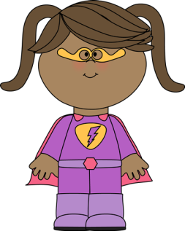 Squirrel Lodge

Dear Parents/Carers
As part of the “Supertato” story we are going to have a Superhero dress up day on the Thursday 25th May. The children are welcome to dress up as their favourite superhero characters.
Thank You Squirrel Lodge

