How to make play dough.
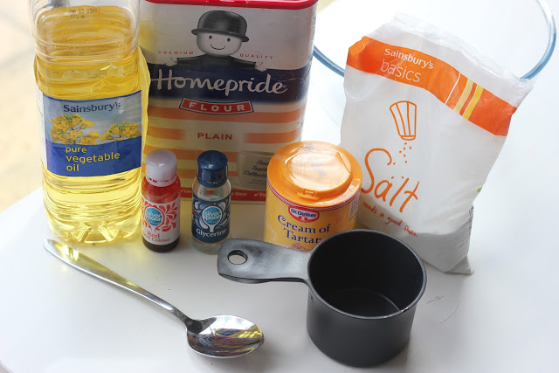

Recipe 1
Materials
- 1 cup water
- 1 tablespoon vegetable oil
- 1/2 cup salt
- 1 tablespoon cream of tartar
- Food coloring (optional)
- Saucepan
- 1 cup flour
Directions
- Combine water, oil, salt, cream of tartar, and food coloring in a saucepan and heat until warm.
- Remove from heat and add flour.
- Stir, then knead until smooth. The cream of tartar makes this dough last 6 months or longer, so resist the temptation to omit this ingredient if you don't have it on hand.
- Store this dough in an airtight container or a Ziploc freezer bag.

Recipe 2
Materials
- 1 cup salt
- 1 cup water
- 1/2 cup flour plus additional flour
- Saucepan
Directions
- Mix salt, water, and flour in saucepan and cook over medium heat.
- Remove from heat when mixture is thick and rubbery.
- As the mixture cools, knead in enough flour to make the dough workable.

Useful websites (play dough recipes)
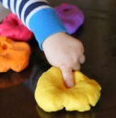
http://theimaginationtree.com/2013/10/10-natural-play-dough-
recipes.html

http://www.familyeducation.com/fun/playdough/6-homemade-playdough-recipes

http://www.instructables.com/id/How-to-Make-Playdough-Play-doh/
http://www.instructables.com/id/How-to-Make-Playdough-Play-doh/

