Squirrel Lodge Autumn 1 2018 Topic - All Bout Me 

Dear Parents/ Carers,

This is an overview of what the children in Squirrel Lodge will be learning during the first half of the Autumn Term.

***Squirrel Lodge Team:***

**Mrs Trow: Room Lead/Foxes**

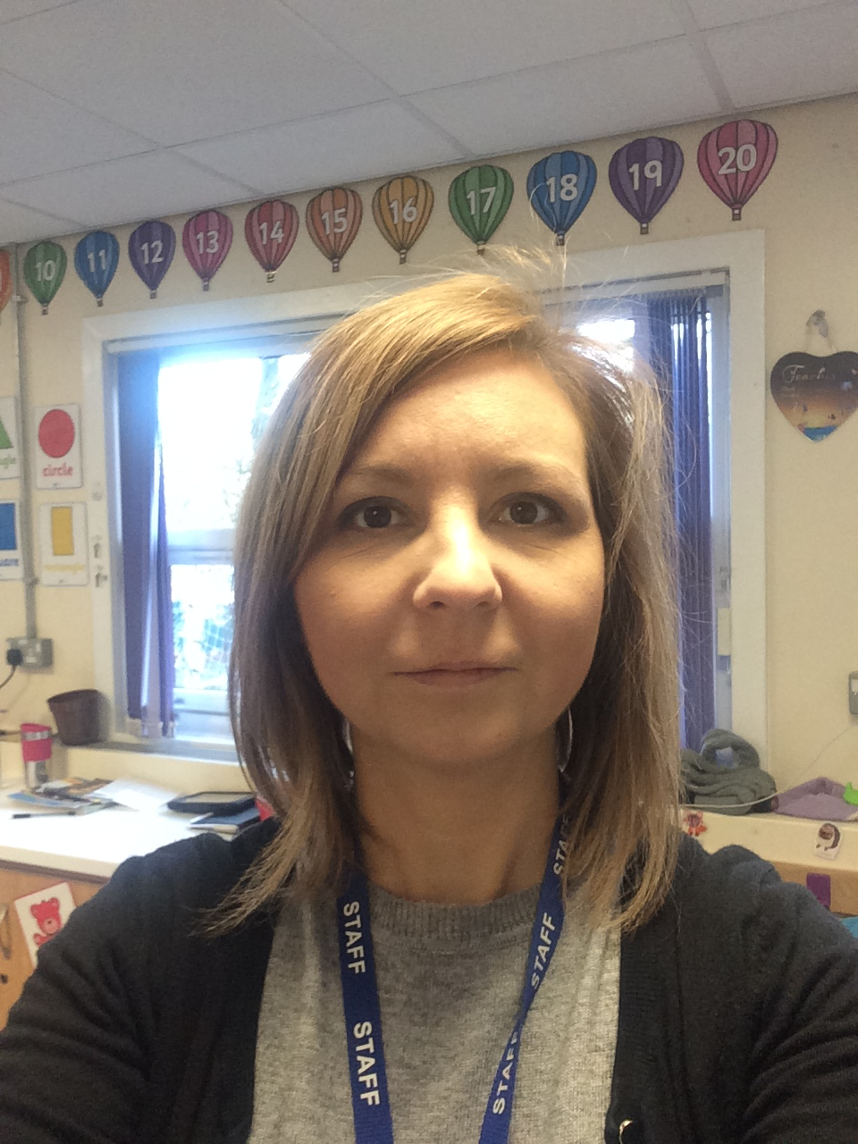

**Mrs Salt: Pre-school Practiioner/Rabbits**

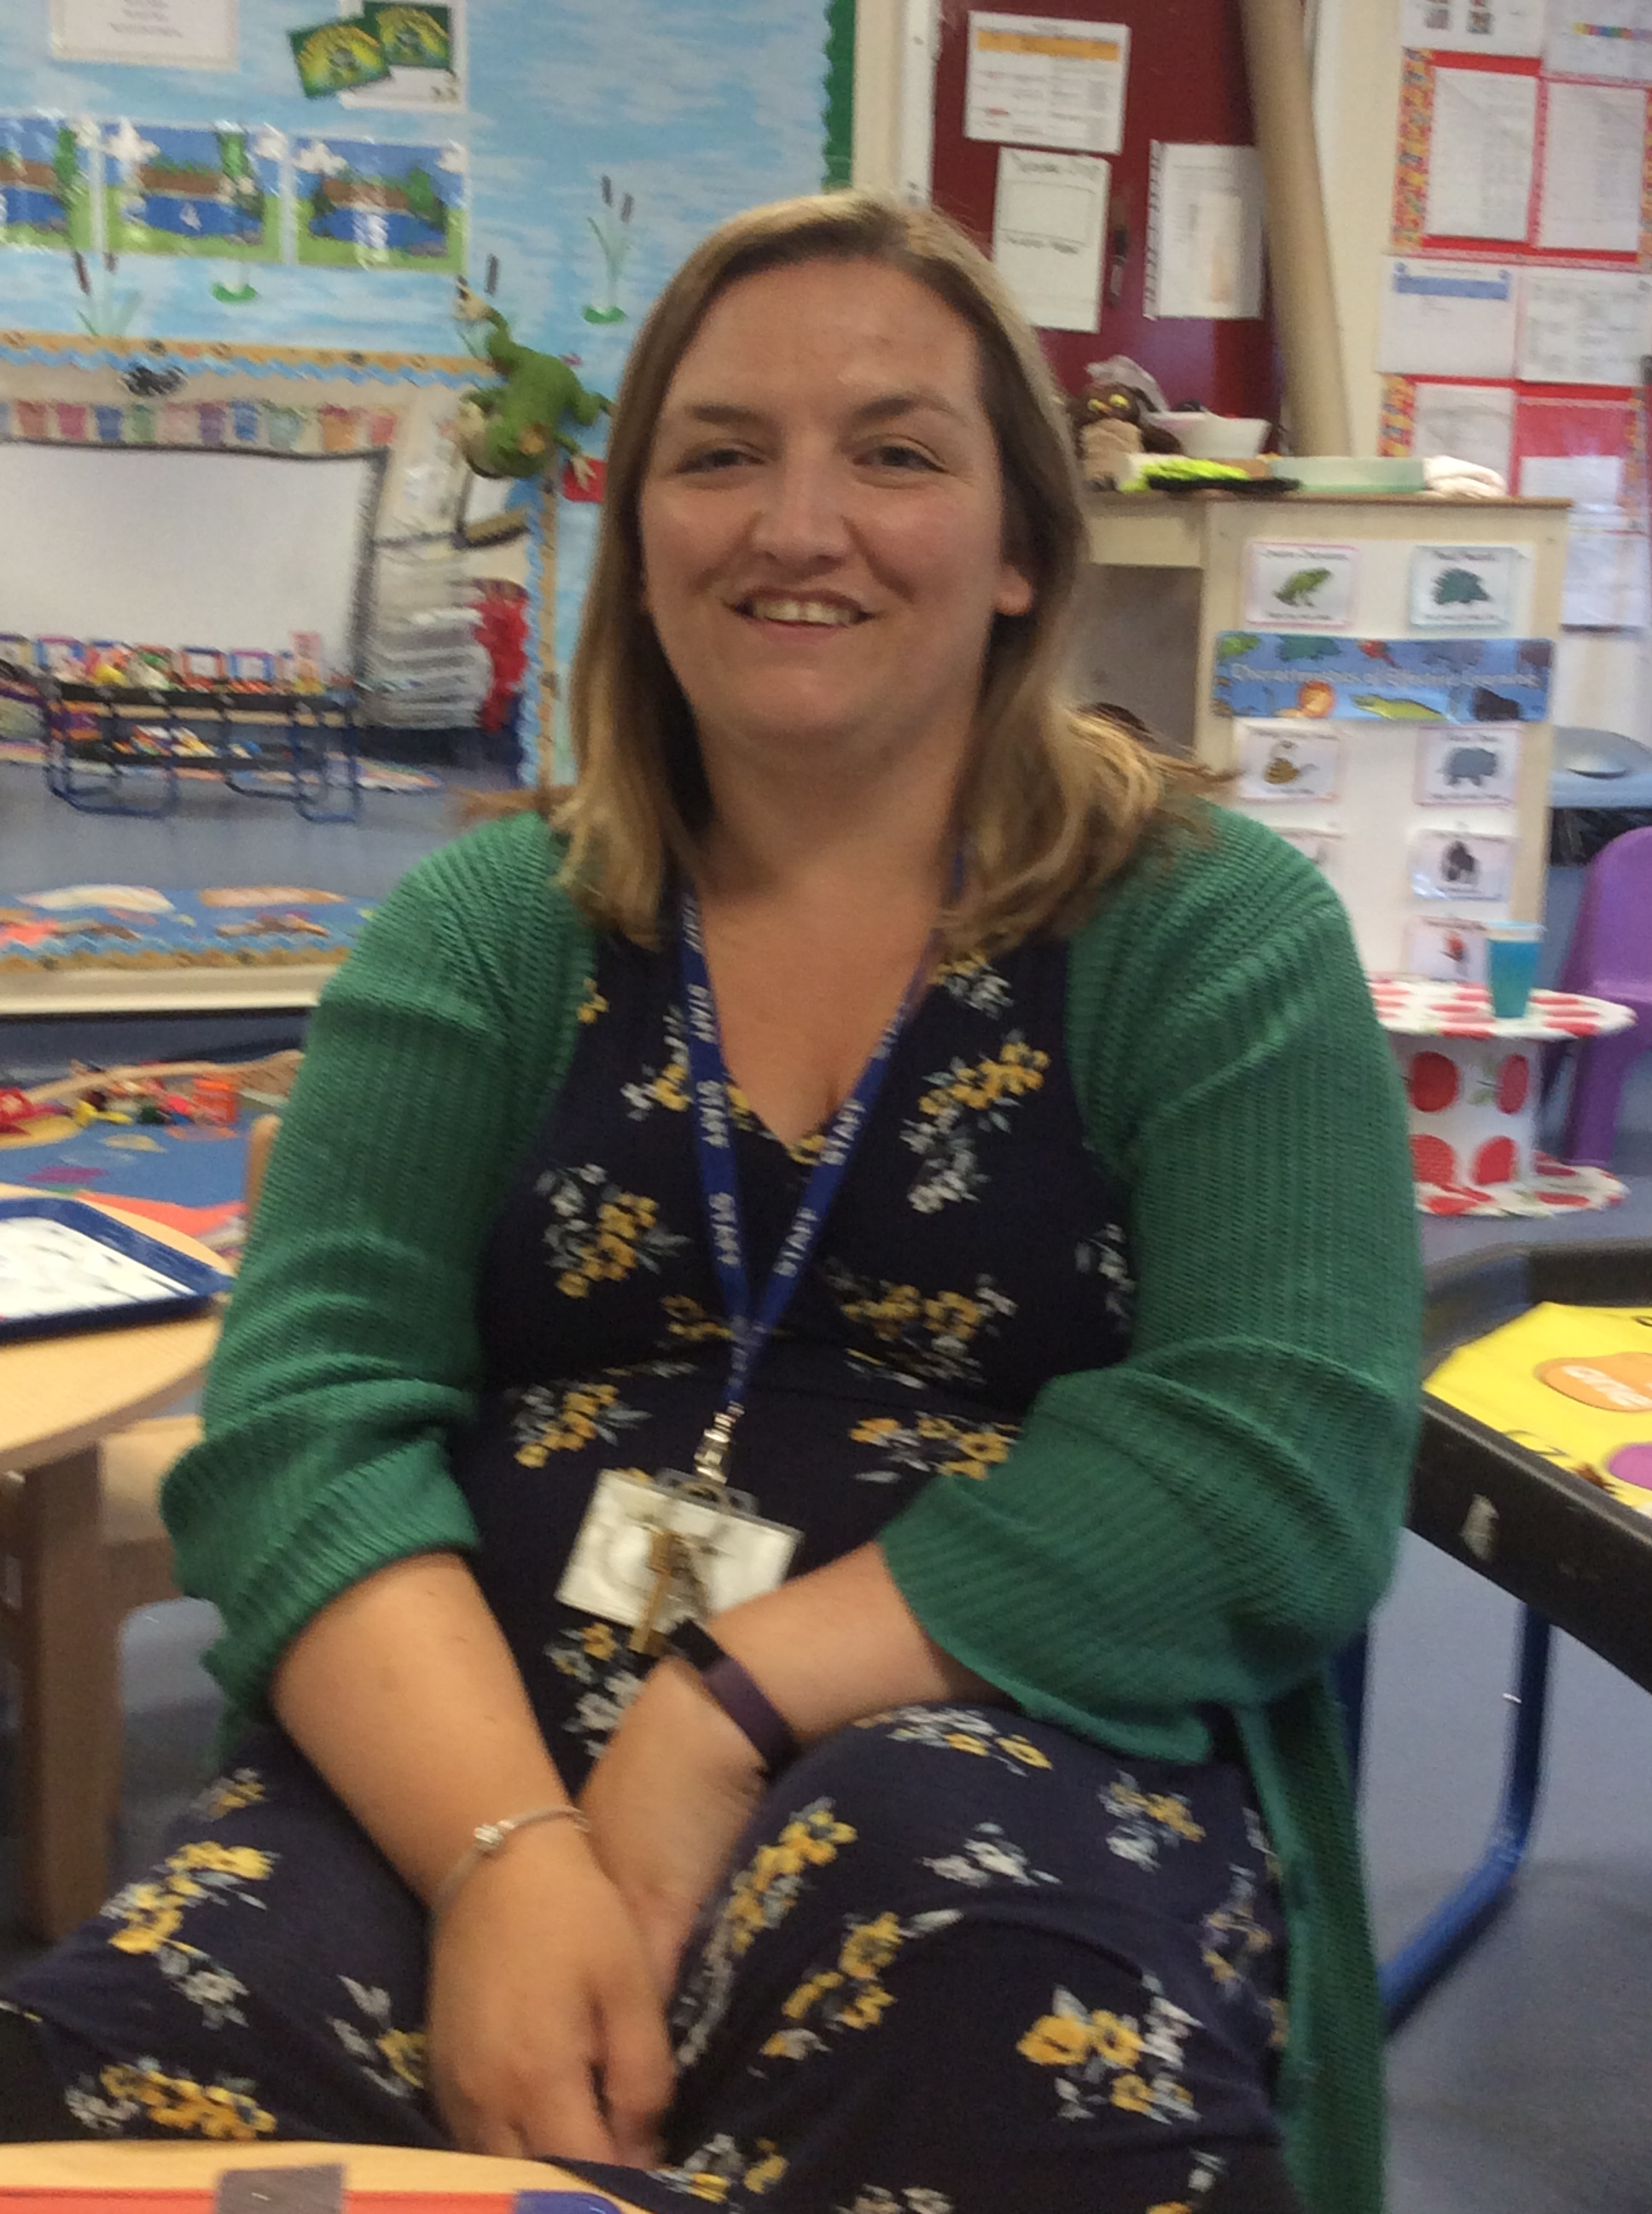

**Miss Clark: Pre-school Practiioner/Squirrels**

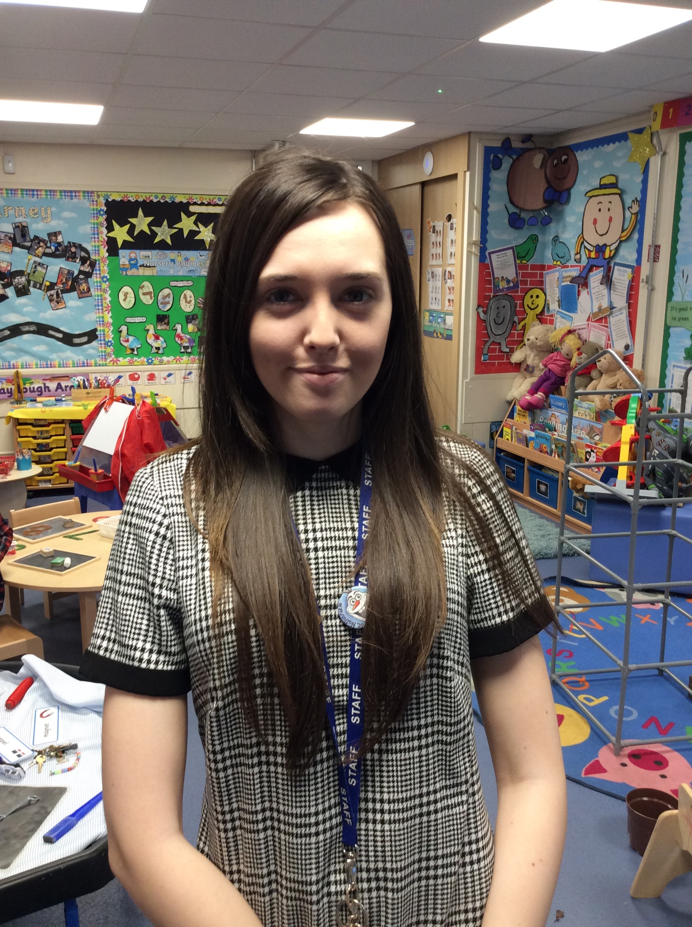

**Miss Holford: Pre-school Practiioner/Hedgehogs**

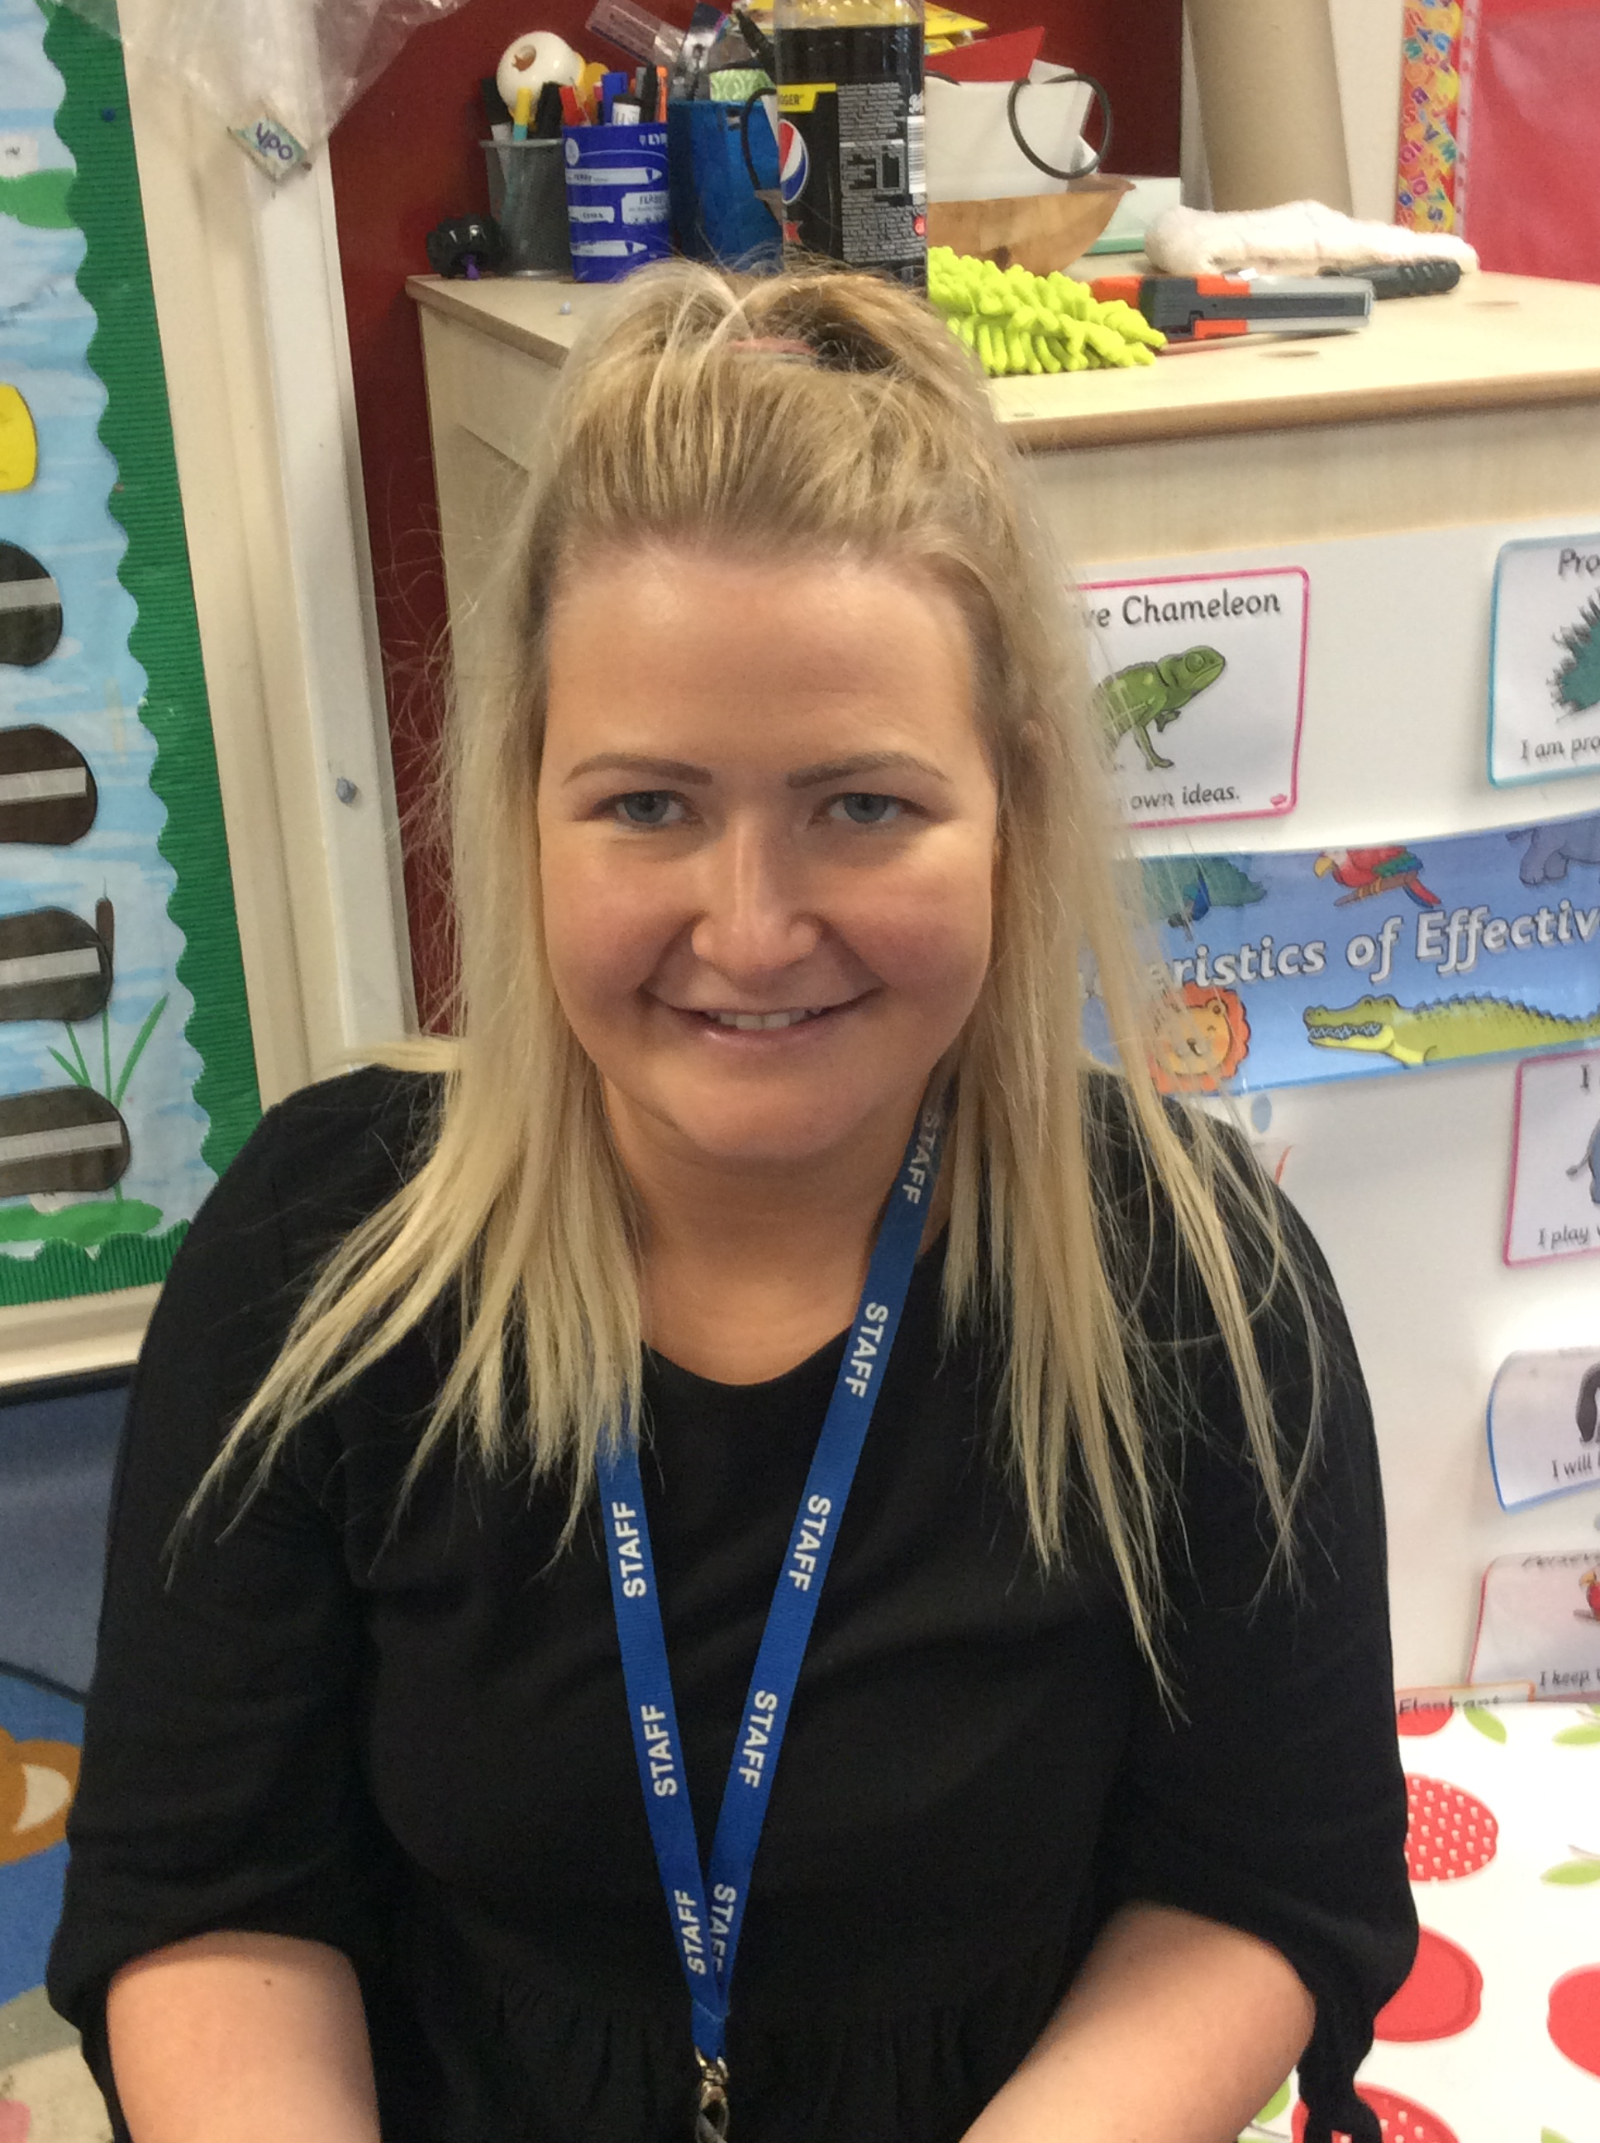

*.*

**Reading**

The children will be reading lots of different books with the focus being on ‘All About Me’

[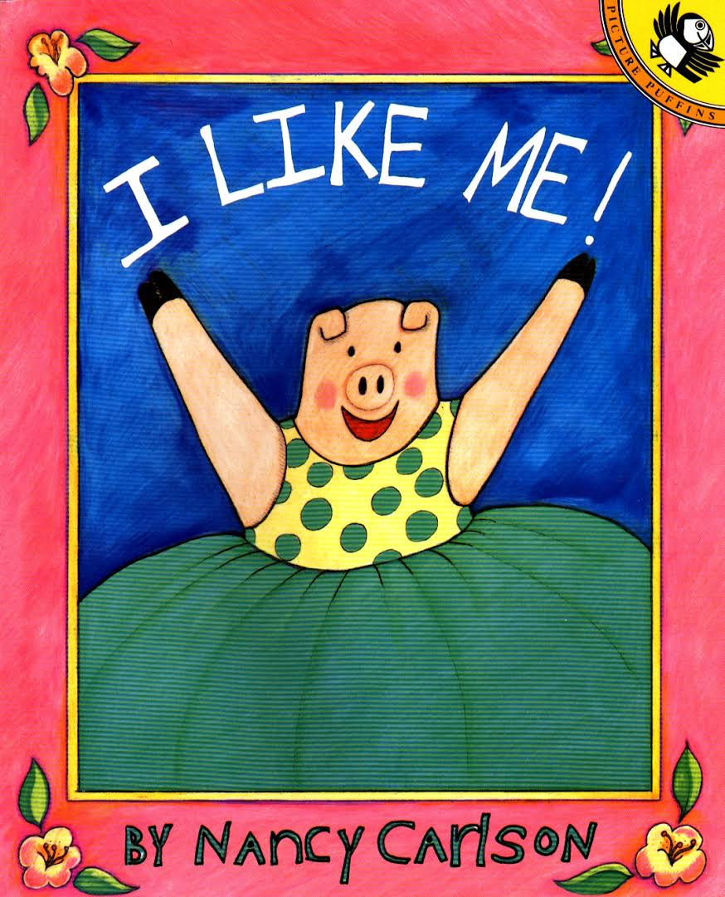](https://www.google.com/url?sa=i&rct=j&q=&esrc=s&source=imgres&cd=&cad=rja&uact=8&ved=&url=https://books.google.com/books/about/I_Like_Me.html?id%3DPLovzMJRh8cC%26source%3Dkp_cover&psig=AOvVaw3TnPS4y7npGXTP3nNyS--1&ust=1535794035450872)   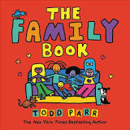

**Mark making/Writing/Physical Development**

The children will be mark making both indoor and outdoor. They will be encouraged to use their gross motor control by kicking and throwing balls, using bats, balancing on our equipment and using our climbing frame. The children will be painting and drawing lots of pictures of themselves and their families.

**Communication and Language**

The children will be encouraged to talk about things they observe and enjoy doing. We will discuss home life and family members. The children will also be encouraged to use their listening skills through phonics activities and circle time. We will be learning new songs and rhymes, such as, ‘twinkle twinkle’ and ‘humpty dumpty’. See ‘You Tube’ for songs.

**Mathematics**

This term we will focus on recognising and counting numbers 1 to 5.

We will be singing number songs such as 1,2,3,4,5 once I caught a fish alive. We will also be encouraging the children to match objects to numbers.

**Personal, Social and Emotional Development**

We will be encouraging the children to interact and play with their friends by, sharing toys and being friendly. We will begin to learn the classroom rules and timetable. The children will also learn how to self register using their own photos.

***Transition into Squirrel Lodge***

*This term our focus will be aimed at settling your child into Squirrel Lodge, ensuring they are happy and settled. The Squirrel Lodge team will be available everyday to discuss any concerns you may have.*

**Understanding the World**

The children will be vising Bob’s Garden to explore the outdoor environment, looking for frogs and other minibeasts. We will be using the ipads to look at photos of themselves and interact with pre-school games.

**Being Imaginative and Music**

This term our role play in the classroom will be a home corner. In the outdoor area the children can role play in the wooden house, experiment with musical instruments and sing on our stage area. If your child has a favourite song they like to sing and dance to please let us know.